
Lab Report 13
Data Communication & Computer Networks


Submitted To:
Engineer Shehzad Malik
Submitted By:
Sumama Rahim
F24BSCS039
BS CS (F24-A-Morning)
Date: 12/29/2025
LAB REPORT – 13
Cisco Packet Tracer – Trunking

Topology:

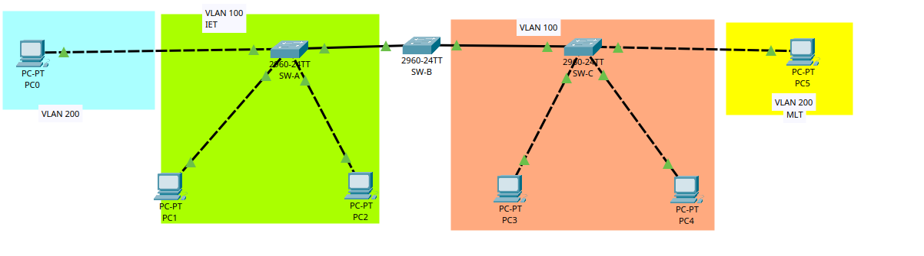

Task 1: Setting IP to PC0

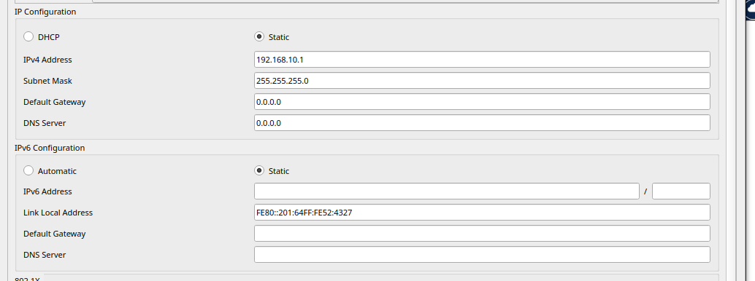
Task 2: PC1

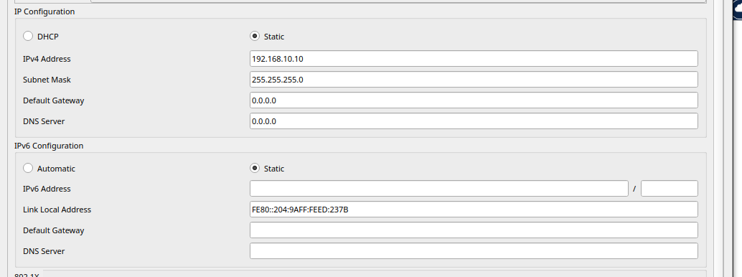

Task 3: PC2

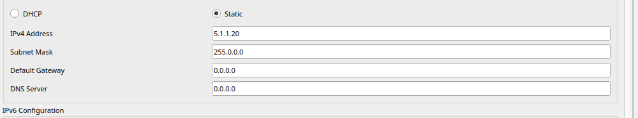
Task 4: PC3

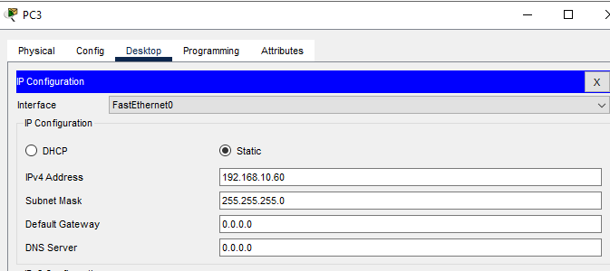

Task 5: PC4
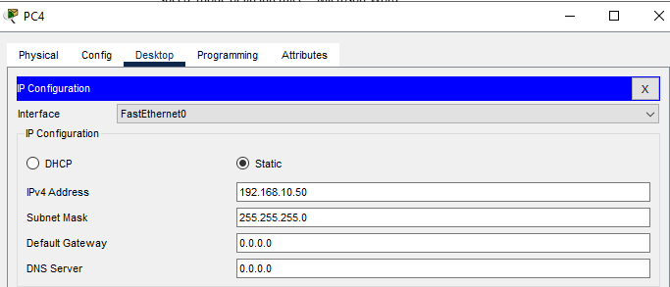

Task 6: PC5

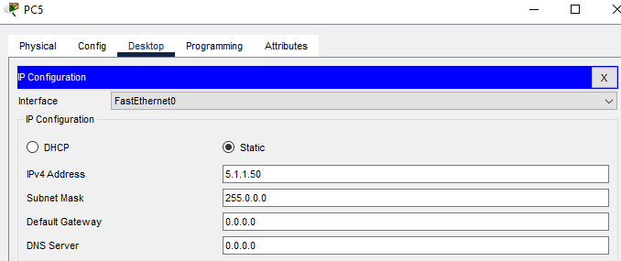

Task 7: Making trunk on Switch1

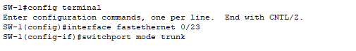
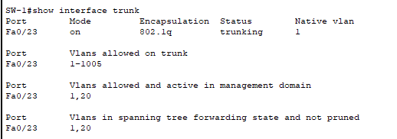

Task 8: Making trunk on Switch2
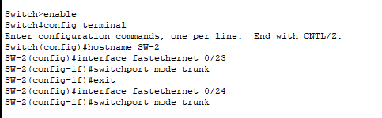
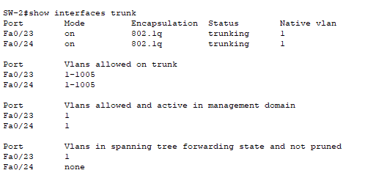

Task 9: Making trunk on Switch3
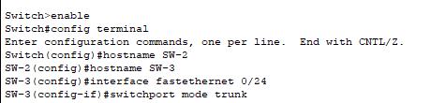
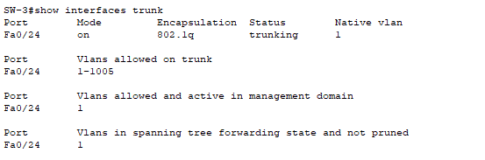

Task 10: Making VLAN on Switch1
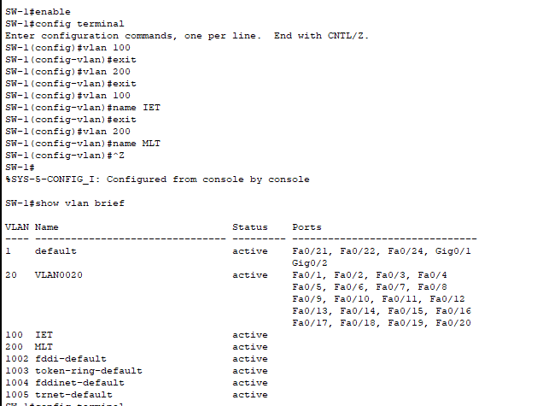

Task 11: Making VLAN on Switch2
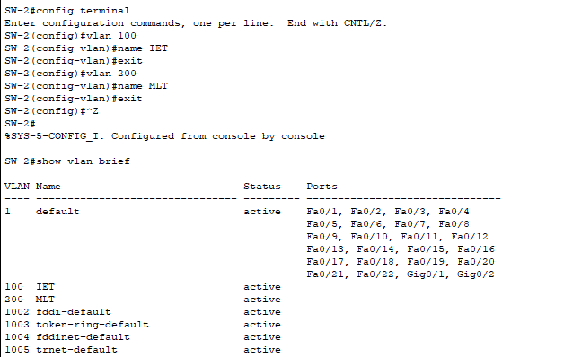

Task 12: Making VLAN on Switch3
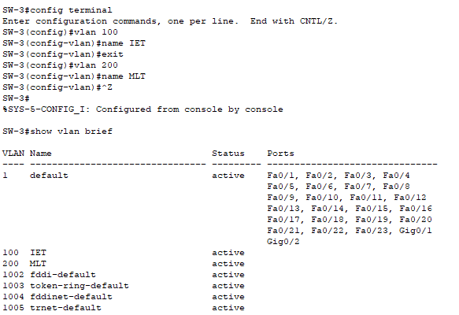

Task 13: Creating VLAN membership on Switch1
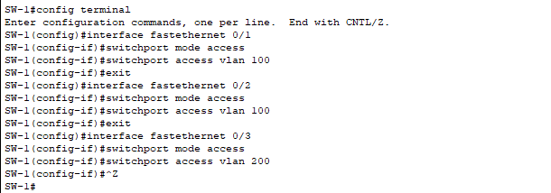
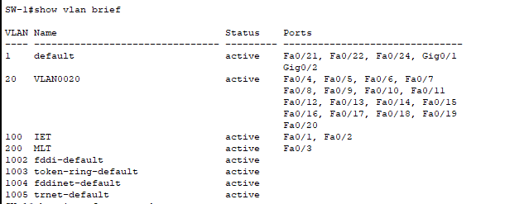

Task 14: Creating VLAN membership on Switch3

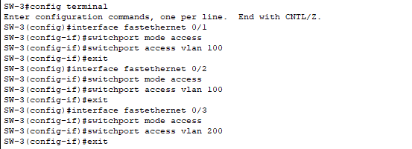
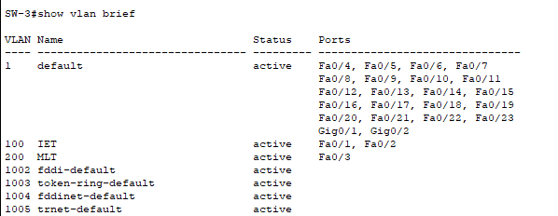

Conclusion
Only same VLAN PCs will pingable to each other but connected all PCs.

The End

